**Government Arts & Science College, Calicut**

**Palliative Care Unit**

**Activity report for the year 2019-20**

Teacher Coordinator : Dr. Muneer C.P(Dept. of Chemistry)

Members: Smt. Raagi(Dept. of English), Rejila(Dept. of Hindi), Subha(Dept. of Commerce)

Student Coordinators : Muhammed Khaleel II B.Sc. Chemistry (Boy)

Irfana II B.A Economics(Girl)

1. **Selection of new student coordinators**

In the meeting of volunteers of second and third year UG held on 27.6.2019 at 1pm, Muhammed Khaleel II B.Sc. Chemistry (Boy) and Irfana II B.A Economics were selected as the new student coordinators for the year. The activity report of the previous year was presented by the outgoing coordinator Smt. Anusree.

1. **Meeting of volunteers**

A number of meetings of all volunteers were convened in order to discuss and decide various activities for the current year. Meeting was held on 3.7.2019 at 1pm, on 16.7.2019 at 1pm, on 23.10.2019 at 1pm and on 9.1.2020 at 1 pm.

1. **Blood Group Directory**

A blood group directory was created by a survey among student donors on 17.7.2019. The directory had been very useful in helping needy patients in emergency.

1. **Palliative Patients’ Camp**

Our volunteers extended their service in the Palliative Patients’ Get together and Medical Camp organized by Daya Charitable Trust, Areekkad on 22.7.2019.

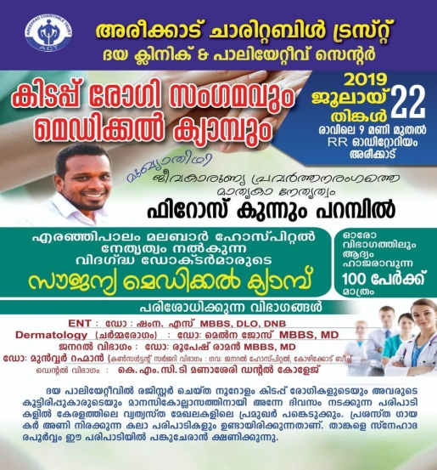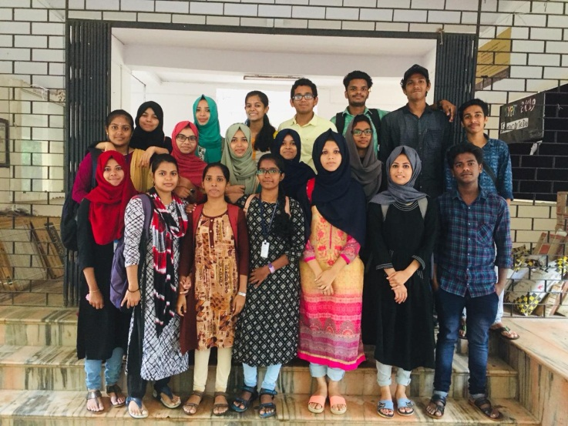

1. **Flood relief campaign (Kaithangu)**

Educational aids like note book, pen, pencil etc were collected from staff and students of the college to give back to those who lost everything in flood. The distribution was done in association with Daya Charitable Trust, Areekkad on 31.8.2019.

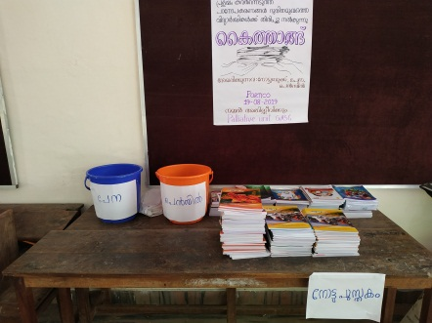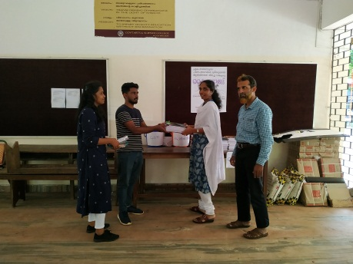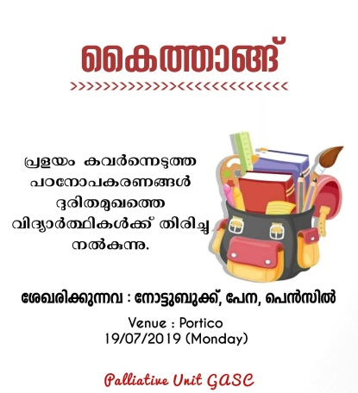

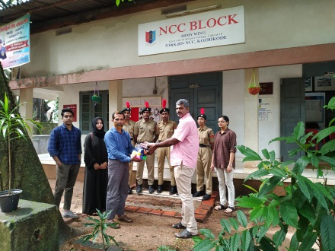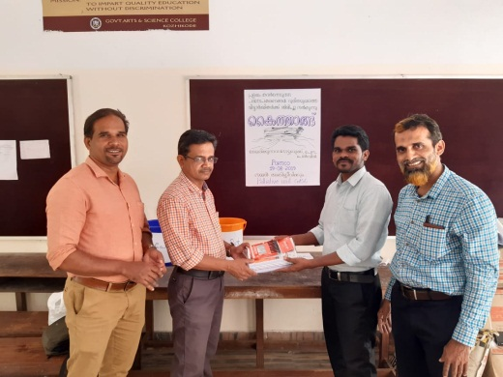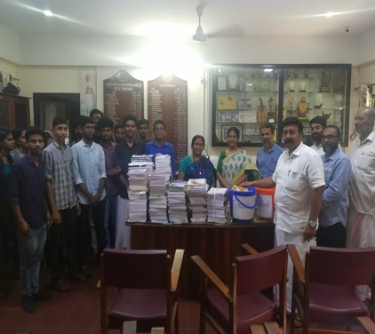

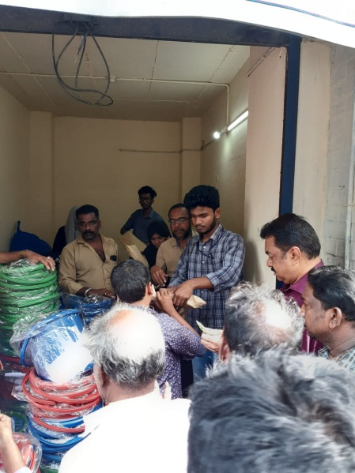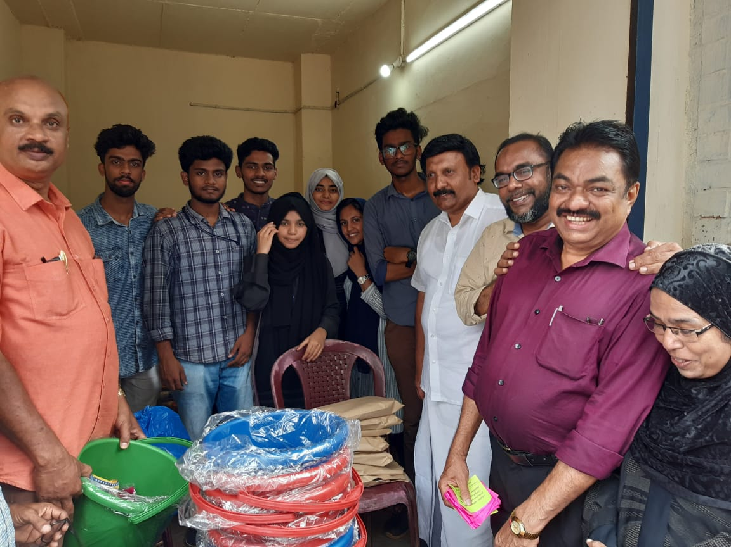

1. **Enrolment of new volunteers**

New volunteers were enrolled from first year UG classes. A meeting of the new volunteers were held on 18.7.2019. A PPT was presented on the activities of the unit so far. Student coordinator Muhamed Khaleel presented the action plan for the year.

1. **Skip a tea and ease a life**

In continuation to last year, charity was collected from students and staff of the college in different months, for the treatment of cancer patients of Institute of Palliative Medicine, Kozhikode. The amount was handed over to IPMK was Rs. 6300/- on 26.10.2019.

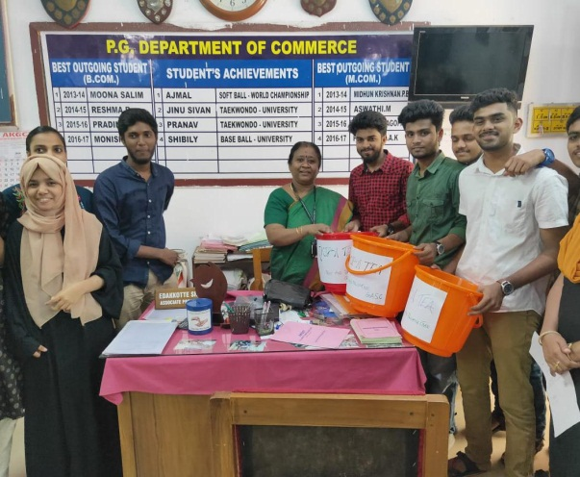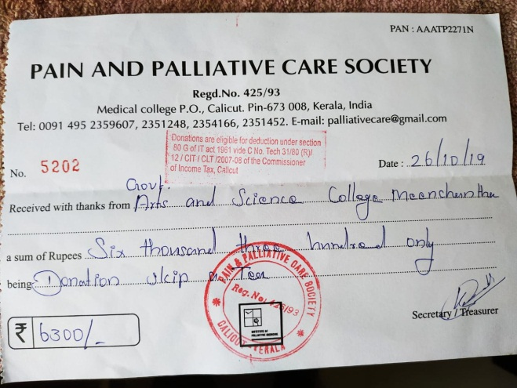

1. **Orientation Programme for new volunteers**

An Orientation Programme was organized for the newly enrolled volunteer on 4.10.2019 at 2 pm at Chemilion. The resource person from IPMK, Mr. Sathyan took the class. 45 students attended the programme.

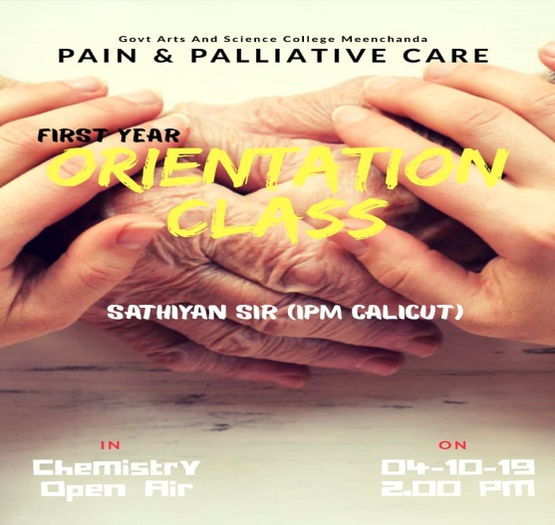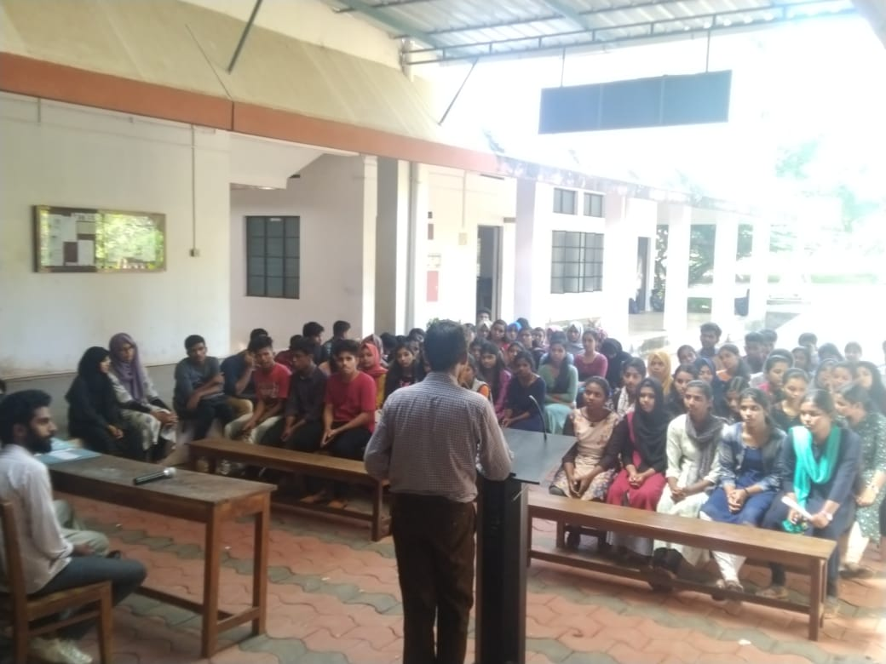

1. **World Mental Health Day (October 10)**

In connection with world mental health day, a team of volunteers visited the house of Mr. Chandran, Nallur, Feroke on 10.10.2019 and handed over a sum of Rs. 1500/- towards the treatment of his mentally disabled daughter. Himself and his wife are also sick.

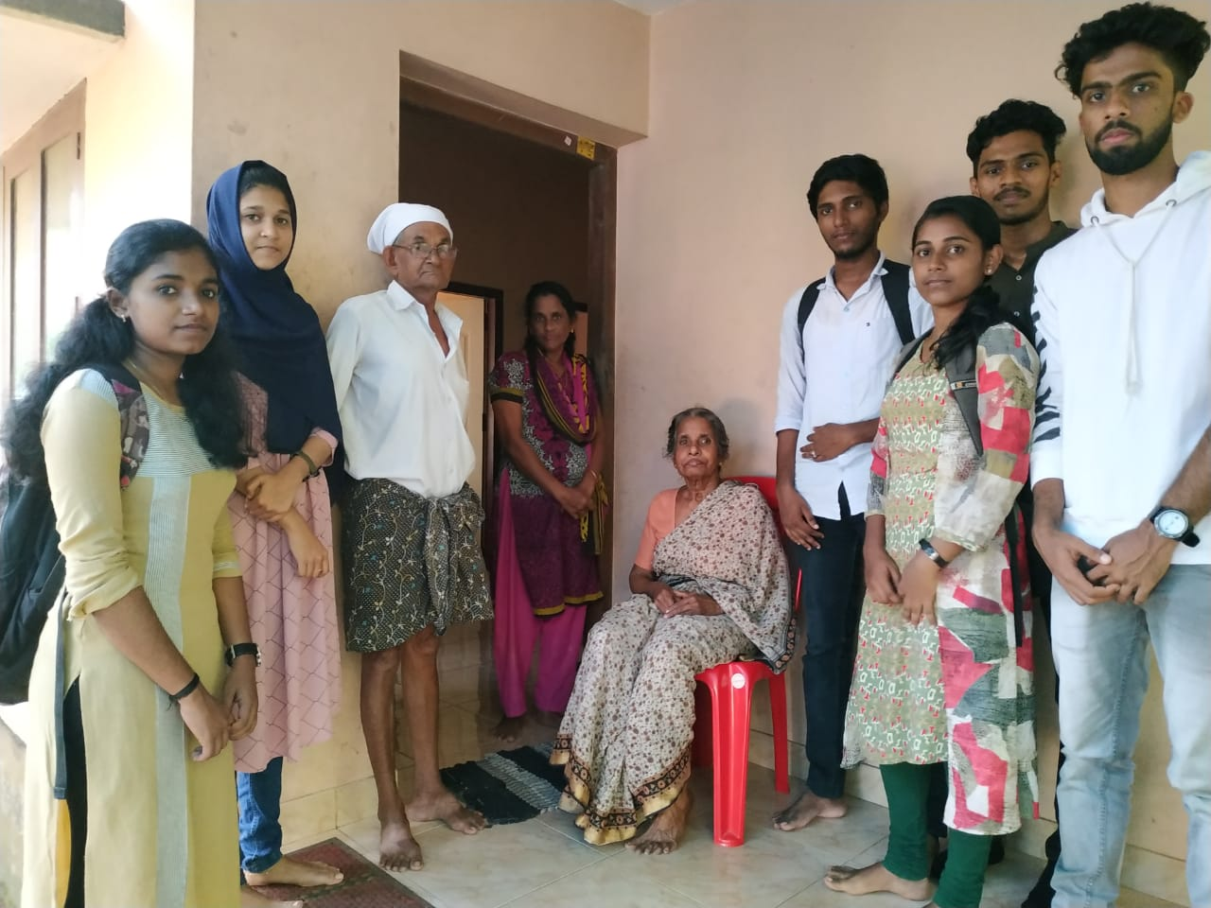

1. **World Palliative Day(October 12)**

In connection with World Palliative Day, thematic posters were exhibited on the theme of the year “My Care My right”. A fund raising campaign was held which amounted Rs. 7650/-.

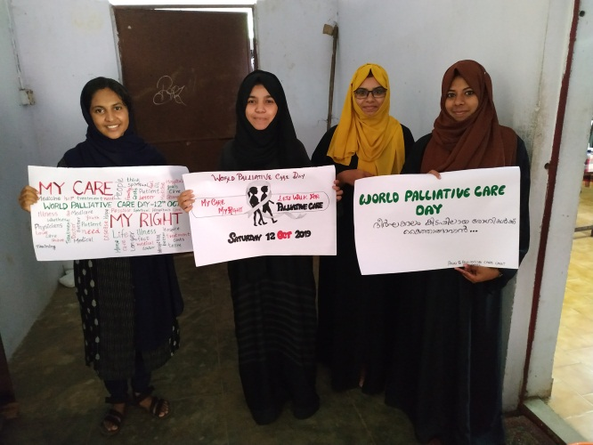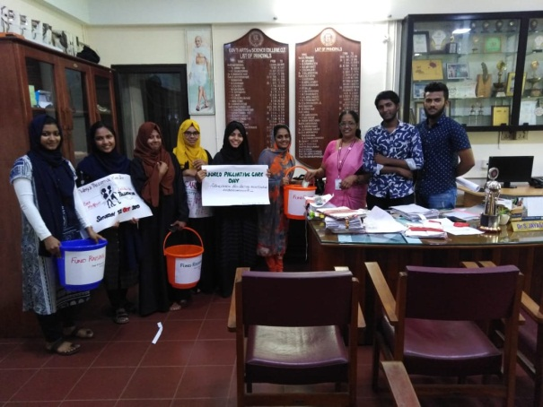

1. **Financial Assistance**

An amount of Rs. 2000 was given to Mr. Thanakai velavan, a person of multiple disorder, for his treatment.

1. **SPARSHAM 2019**

6 volunteers of our unit attended the programme organized by OASIS Palliative Care Unit of Govt. Engineering College, Thrissur on 25.10.2019 and participated in various competitions.

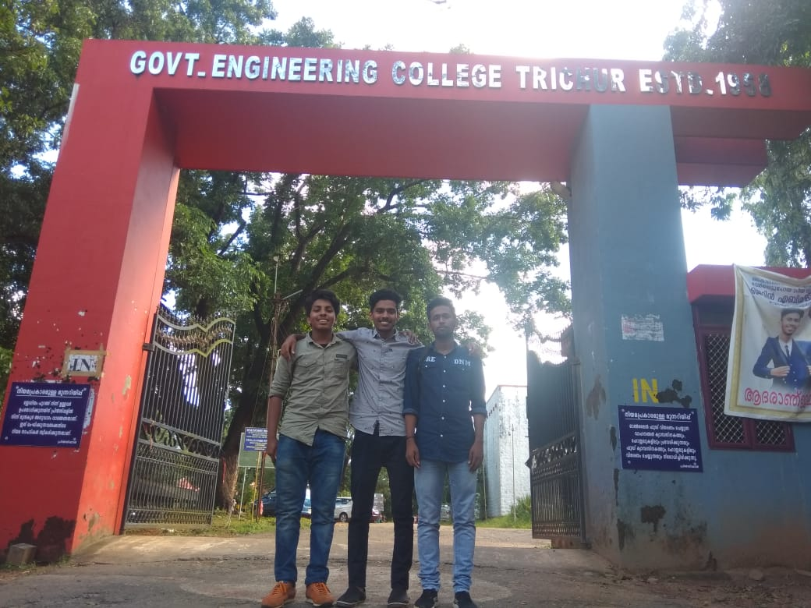

1. **Samvedanam**

40 volunteers attended a basic training programme, named “Samvedanam”, recognized by WHO, held on 26.10.2019 at IPMK. Certificate was issued to the participants.

